Business Vision

منصه داجن (Dajin Portal)

User Stories

**Prepared by:** **Samia Shabaan**

**Prepared for: Dajin Portal**

**Last Updated: 05 December 2021**

**Creation Date: 05 December 2021**

# Epic1 (Trader registration): User story 3

## Description:

As A new Trader I want to be able to register an account so that I can access Dajin portal

## Business Logic:

1. Trader download App or from Portal
2. Open registration screen
3. Trader enter registration data

* Name
* Address
* Contact details
* ID copy
* Activity type
* poultry farming type
* breeding breed
* Farms No
* Farm capacity
* Attachments
* Invitation code
* Interests

1. Trader enter password.
2. Trader reenter password again.
3. System save farm with status pending on approval.
4. System send to the Trader verification code (User Story4)
5. After enter success verification code . System change Trader status to active.
6. System request from Trader to enter X Farms which deal with it.
7. Trader can search on farm by (Gov., Area, Farmer, and Mobile No).
8. System returned frames according Search items.
9. Trader know X frames to select frames from returned result.
10. If Trader not Know frames Trader Recommend Farms Data.
11. System Save Trader Profile with status pending on Approval.
12. Admin review Trader Profile If Trader data valid.
13. Admin convert Trader status to Active.
14. System send notification to Trader that his account is active.
15. If Trader data not valid ,Admin convert Trader status to Inactive

## Data Dictionary:

|  |  |  |  |  |
| --- | --- | --- | --- | --- |
| **Filed Name (EN)** | **Filed Name (Ar)** | **Data type** | **Mandatory** | **Comments** |
| **Name** | اسم المربي | String | Yes |  |
| **Address**   1. **Gov** 2. **City** 3. **Area** 4. Detailed address | العنوان   1. المحافظة 2. المدينة 3. المنطقة /الحي 4. العنوان التفصيلي | 1.       Lookups  2.       Lookups depend on Gov  3.       String  4.       String  5.       String | yes |  |
| **بيانات الاتصال**   * 1. Mobile no   2. Email   3. Facebook account   4. What ‘up | 1. التليفون 2. البريد الاليكتروني 3. حساب الفيس بوك 4. الواتس اب | 1.       number(11)  2.       String (email format)  3.       String(char50)  4.      Number(11) | 1.Yes  2.Yes  3.No  4.No |  |
| **Password** | كلمه المرور | string "capital, small, numbers, special chr" | Yes |  |
| **Reenter Password** | اعاده دخول كلمه المرور | Match password |  |  |
| **ID No** | صورة البطاقة | Number (14) | Yes |  |
| **Activity type** | نوع النشاط | Radio button | Yes | فردي ، شركة |
| **Poultry farming type** | نوع التربية | **L**ookup  Multiselect | **Yes** | أرضي ، بطاريات |
| **breeding breed** | سلالة التربية | lookup  Multiselect | Yes | أبيض ، ساسو ، فيومي ، بط ، حمام ، سمان |
| **Farms No** | عدد عنابر التربية | Number | No | من 1 – 100 |
| **Farms capacity** | سعه العنابر | Lookup | No | أقل من 1000  أقل من 5000  أقل من 10000  أقل من 100000 |
| **attachments** | المرفقات | Images(PNG, PDF, JPG) max 5mb | No |  |
| **Invitation code** | كود التوثيق | String(10) | No |  |
| **interests** | الاهتمامات | Lookup(multiselect) | No |  |

Acceptance Criteria:

1. The system must display a success message after creation
2. Trader Enters Trader User Account Information
3. If during Create Account, the system determines that the Trader entered invalid *User Account* information, the following occurs:

* The system describes which entered data was invalid and presents the Trader with suggestions for entering valid data.
* The system prompts the Trader to re-enter the invalid information.
* The Trader re-enters the information and the system re-validates it.
* If valid information is entered, the Trader Account Information is stored.
* If invalid information is entered, the Entered Information is Invalid alternative flow is executed again. This continues until the Trader enters valid information, or chooses Cancel (see the User Cancels Account Management Request alternative flow).

1. Invalid User Account information:

* Missing information items
* Missing error message appeared to customer
* Mobile or Email already exists in the system
* The system displays a message indicating that this is an active Trader account.
* User Account information entered does not comply with its definition in the data validation table
* Not well formed e-mail address

1. Problems on Internet Connection

* Warn the Trader about the problem with a message
* The screen is back to the main screen of Register New Trader

1. Trader Cancels registration
   * At any time, the Trader may choose to cancel the account creation. At which point, the processing is discontinued, and the Trader is notified that the account management request has been cancelled.

# Flow:

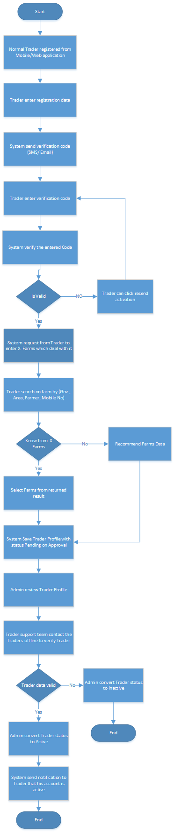

# Epic1 (Trader registration): User story 4

## Description:

As A new Trader I want to be able to verify my mobile no so that I can continue my account creation (registration)

## Business Logic:

1. System will send verification code (one time password) to Trader
2. Trader should enter verification code
3. System validate the code
4. If the code is correct then Mobile will be verified
5. Else Trader can Resend Verification code in case he didn’t receive code

Data Dictionary

|  |  |  |  |  |
| --- | --- | --- | --- | --- |
| **Filed Name (EN)** | **Filed Name (Ar)** | **Data type** | **Mandatory** | **Comments** |
| **Verification code** | الرمز التحقيقي | Number (4 or 6) | Yes |  |

## Validation:

1. If code is not valid message should appear “verification code is not valid”
2. Verification code will expire in configured time ( ex 30 sec, 60 sec)